Select * From Swiggy_Data;
Data Cleaning
Check for Null values in Each Column
SELECT
SUM(CASE WHEN State IS NULL THEN 1 ELSE 0 END) AS null_state,
SUM(CASE WHEN City IS NULL THEN 1 ELSE 0 END) AS null_city,
SUM(CASE WHEN Order_Date IS NULL THEN 1 ELSE 0 END) AS null_Order_Date,
SUM(CASE WHEN Restaurant_Name IS NULL THEN 1 ELSE 0 END) AS null_Restaurant_Name,
SUM(CASE WHEN Location IS NULL THEN 1 ELSE 0 END) AS null_Location,
SUM(CASE WHEN Category IS NULL THEN 1 ELSE 0 END) AS null_Category,
SUM(CASE WHEN Dish_Name IS NULL THEN 1 ELSE 0 END) AS null_Dish_Name,
SUM(CASE WHEN Price_INR IS NULL THEN 1 ELSE 0 END) AS null_Price_INR,
SUM(CASE WHEN Rating IS NULL THEN 1 ELSE 0 END) AS null_Rating,
SUM(CASE WHEN Rating_Count IS NULL THEN 1 ELSE 0 END) AS null_Rating_Count
from Swiggy_Data;

Blank/Empty String Check
Detect fields containing blank values that may cause inaccurate analysis.

SELECT *
FROM Swiggy_Data
WHERE
State='' OR City='' OR Restaurant_Name='' OR Location='' OR Category=''OR Dish_Name='';
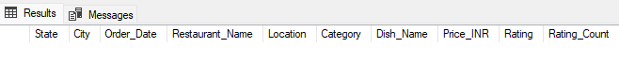
Duplicate Detection
Find duplicate rows using grouping on all business-critical columns.

Select
State, City, Order_Date, Restaurant_Name, Location, Category,
Dish_Name, Price_INR, Rating, Rating_Count, Count(*) As CNT
from Swiggy_Data
group by
State, City, Order_Date, Restaurant_Name, Location, Category,
Dish_Name, Price_INR, Rating, Rating_Count
Having Count(*)>1;

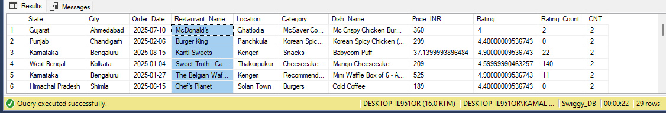

Duplicate Removal
Use ROW_NUMBER() to delete surplus duplicate rows while retaining one clean copy for each unique order.

WITH CTE AS(
SELECT * ,ROW_NUMBER() OVER(
PARTITION BY State, City, Order_Date, Restaurant_Name, Location, Category,
Dish_Name, Price_INR, Rating, Rating_Count
ORDER BY (SELECT NULL)
)AS RN
FROM Swiggy_data
)
DELETE FROM CTE WHERE RN>1
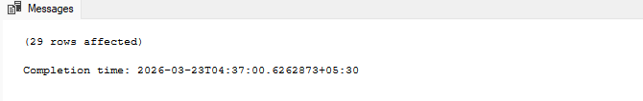

Dimensional Modelling (Star Schema)

CREATING SCHEMA
DIMENSION TABLE
DATE TABLE

CREATE TABLE dim_date(
date_id int Identity(1,1) PRIMARY KEY,
FULL_DATE Date,
Year INT,
Month INT,
Month_name VARCHAR(20),
Quarter INT,
Day INT,
Weeek INT
);

---Dim Location
Create Table dim_location(
Location_id int identity(1,1) PRIMARY KEY,
State VARCHAR(100),
City VARCHAR(100),
Location VARCHAR(200)
);

---Dim Restaurant
Create table dim_restaurnat(
Restaurnat_id int identity(1,1) PRIMARY KEY,
Restaurnat VARCHAR(200)
);

---Dim Category
Create table dim_category(
Category_id INT IDENTITY(1,1) PRIMARY KEY,
Category VARCHAR(200)
);

---Dim Dish
Create Table dim_dish(
Dish_id INT IDENTITY(1,1) PRIMARY KEY,
Dish_name VARCHAR(200)
);

--Fact Table
Create Table fact_Swiggy_ordrs(
Order_id int identity(1,1) PRIMARY KEY,

date_id INT,
Price_INR DECIMAL(10,2),
Rating DECIMAL(4,2),
Rating_count INT,

Location_id INT,
Restaurnat_id INT,
Category_id INT,
Dish_id INT,

FOREIGN KEY (date_id) REFERENCES dim_date(date_id),
FOREIGN KEY (location_id) REFERENCES dim_location(location_id),
FOREIGN KEY (Restaurnat_id) REFERENCES dim_restaurnat(Restaurnat_id),
FOREIGN KEY (Category_id) REFERENCES dim_category(Category_id),
FOREIGN KEY (Dish_id) REFERENCES dim_dish(Dish_id)
);

INSERT DATA IN ALL TABLES
Dim_Date Table

INSERT INTO dim_date(FULL_DATE, Year, Month, Month_name, Quarter, Day, Weeek)
SELECT DISTINCT
Order_Date,
Year(Order_Date),
Month(Order_Date),
DATENAME(MONTH,Order_Date),
DATEPART(QUARTER,Order_Date),
DAY(Order_Date),
DATEPART(Week, Order_Date)
from Swiggy_Data
where Order_Date is not null;

dim_location
INSERT INTO dim_location(State, City, Location)
select Distinct
State,
City,
Location
from Swiggy_Data;

dim_restuarnat
INSERT INTO dim_restaurnat(Restaurnat)
SELECT DISTINCT
Restaurant_Name
from Swiggy_Data;

dim_category
INSERT INTO dim_category(Category)
SELECT DISTINCT
Category
from Swiggy_Data;

dim_dish
INSERT INTO dim_dish(Dish_name)
SELECT DISTINCT
Dish_Name
FROM Swiggy_Data;

INSERT INTO FACT TABLE
INSERT INTO fact_Swiggy_ordrs
(
date_id,
Price_INR,
Rating,
Rating_count,
Location_id,
Restaurnat_id,
Category_id,
Dish_id
)
SELECT
dd.date_id,
s.Price_INR,
s.Rating,
s.Rating_count,

dl.Location_id,
dr.Restaurnat_id,
dc.Category_id,
ds.dish_id
from Swiggy_Data s

join dim_date dd
ON dd.FULL_DATE=s.Order_Date

join dim_location dl
ON dl.State=s.State
and dl.City=s.City
and dl.Location=s.Location

join dim_restaurnat dr
ON dr.Restaurnat=s.Restaurant_Name

join dim_category dc
ON dc.Category=s.Category

join dim_dish ds
ON ds.Dish_name=s.Dish_Name

KPI Development

- Total Order
Select count(*) as Total_Orders
from fact_Swiggy_ordrs;

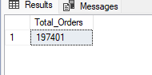

- Total Revenue (INR Million)

SELECT
FORMAT(SUM(CONVERT(float,Price_INR))/1000000,'N2')+'INR Million'
as [Total Revenue]
from fact_Swiggy_ordrs;

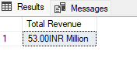
- Average Dish Price

SELECT
FORMAT(AVG(Price_INR), 'N2') + ' INR' AS [Avg Dish Price]
FROM fact_Swiggy_ordrs;

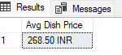
- Average Rating

Select Round(AVG(Rating),0) as [Average Rating]
from fact_Swiggy_ordrs;
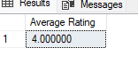
Deep-Dive Business Analysis
Date-Based Analysis
- Monthly order trends

SELECT
d.Year,
d.Month,
d.Month_name,
count(*) as Total_Orders
from fact_Swiggy_ordrs f
join dim_date d on f.date_id=d.date_id
group by
d.Year,
d.Month,
d.Month_name
;
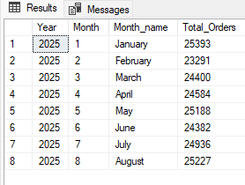

SELECT
d.Year,
d.Month,
d.Month_name,
Sum(Price_INR) as Total_Revenue
from fact_Swiggy_ordrs f
join dim_date d on f.date_id=d.date_id
group by
d.Year,
d.Month,
d.Month_name
Order by Sum(Price_INR) Desc
;

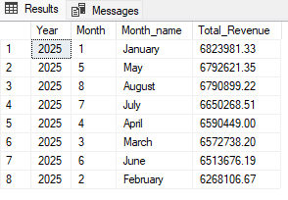

- Quarterly order trends

SELECT
d.Year,
d.Quarter,
count(*) as Total_Orders
from fact_Swiggy_ordrs f
join dim_date d on f.date_id=d.date_id
group by
d.Quarter,
d.Year
Order by count(*) desc
;

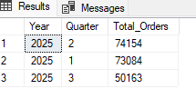
- Year-wise growth
SELECT
d.Year,
count(*) as Total_Orders
from fact_Swiggy_ordrs f
join dim_date d on f.date_id=d.date_id
group by
d.Year
Order by count(*) desc
;

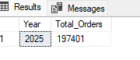
- Day-of-week patterns

SELECT
DATENAME(weekday,d.full_date) as Day_name,
Count(*) as Total_Orders
from fact_Swiggy_ordrs f
join dim_date d on d.date_id=d.date_id
Group by
DATENAME(weekday,d.full_date),
Datepart(weekday,d.full_date)
Order by
Datepart(weekday,d.full_date)
;
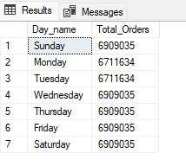
Location-Based Analysis
- Top 10 cities by order volume
SELECT Top 10
l.city,
count(*) As Total_Orders
from fact_Swiggy_ordrs f
join dim_location l
ON l.Location_id=f.Location_id
Group by
l.City
Order by Count(*) desc
;
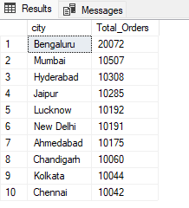

SELECT Top 10
l.city,
sum(f.Price_INR) As Total_Revenue
from fact_Swiggy_ordrs f
join dim_location l
ON l.Location_id=f.Location_id
Group by
l.City
Order by sum(f.Price_INR) ASC
;

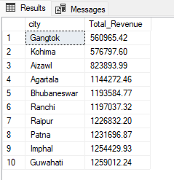

- Revenue contribution by states
SELECT
l.State,
sum(f.Price_INR) As Total_Revenue
from fact_Swiggy_ordrs f
join dim_location l
ON l.Location_id=f.Location_id
Group by
l.State
Order by sum(f.Price_INR) ASC
;
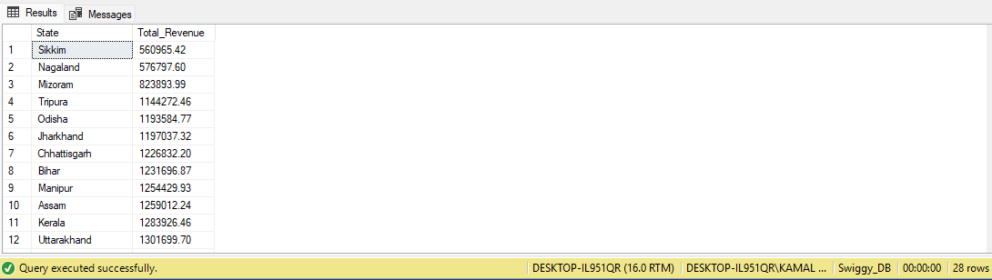

Food Performance
- Top 10 restaurants by orders
SELECT Top 10
R.Restaurnat,
count(*) As Total_Orders
from fact_Swiggy_ordrs f
join dim_restaurnat R
ON R.Restaurnat_id=f.Restaurnat_id
Group by
R.Restaurnat
Order by Count(*) desc
;

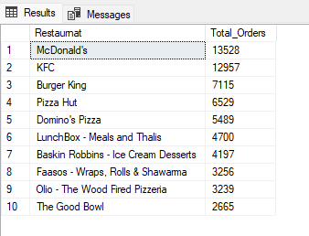
SELECT Top 10
R.Restaurnat,
Sum(F.Price_INR) As Total_Revenue
from fact_Swiggy_ordrs f
join dim_restaurnat R
ON R.Restaurnat_id=f.Restaurnat_id
Group by
R.Restaurnat
Order by Sum(F.Price_INR) desc
;
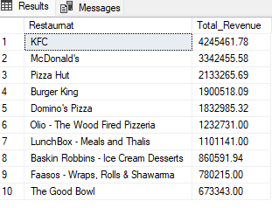
- Top categories (Indian, Chinese, etc.)
SELECT Top 10
C.Category,
count(*) As Total_Orders
from fact_Swiggy_ordrs f
join dim_category C
ON C.Category_id=f.Category_id
Group by
C.Category
Order by Count(*) desc
;
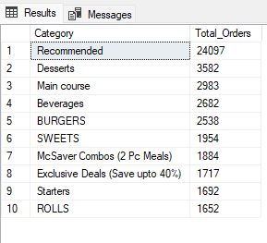
- Most ordered dishes
SELECT Top 10
d.Dish_name,
count(*) As Total_Orders
from fact_Swiggy_ordrs f
join dim_dish d
ON d.Dish_id=f.Dish_id
Group by
d.Dish_name
Order by Count(*) desc
;
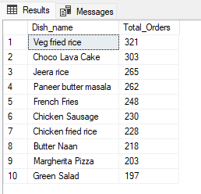
- Cuisine performance → Orders + Avg Rating
SELECT
C.Category,
Count(*) AS Total_Orders,
AVG(f.rating) AS AVG_Rating
from fact_Swiggy_ordrs f
join dim_category c
On c.Category_id=f.Category_id
Group by
C.Category
Order by C.Category Desc
;

Total Order by Price Ranges
SELECT
CASE
WHEN CONVERT(FLOAT,Price_INR) < 100 THEN 'UNDER 100'
WHEN CONVERT(FLOAT,Price_INR) BETWEEN 100 AND 199 THEN '100-199'
WHEN CONVERT(FLOAT,Price_INR) BETWEEN 200 AND 299 THEN '200-299'
WHEN CONVERT(FLOAT,Price_INR) BETWEEN 300 AND 499 THEN '300-499'
ELSE '500+'
END AS Price_range,
count(*) AS Total_Orders
From fact_Swiggy_ordrs
Group by
CASE
WHEN CONVERT(FLOAT,Price_INR) < 100 THEN 'UNDER 100'
WHEN CONVERT(FLOAT,Price_INR) BETWEEN 100 AND 199 THEN '100-199'
WHEN CONVERT(FLOAT,Price_INR) BETWEEN 200 AND 299 THEN '200-299'
WHEN CONVERT(FLOAT,Price_INR) BETWEEN 300 AND 499 THEN '300-499'
ELSE '500+'
END
Order by Total_Orders DESC
;
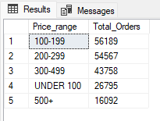

Ratings Analysis
Distribution of dish ratings from 1–5.

Select
Rating,
Count(*) as Rating_count
from fact_Swiggy_ordrs
Group by Rating
Order By Rating DESC
;
